# Practical No: 1

## AIM: Use testing tool such as J-Meter, Canoo Web Test

### Problem:

J-Meter can be used for purpose of load testing and stress testing.

### Procedure:

### In this test, application is tested for Normal load and heavy load by adding number of users.

**Step 1:** Add Users

1. Start J-Meter
2. Select test plant
3. Add user group
4. Add user group to the test plan Let number of users 100 users
5. Loop Count=10 (No of Time a test is executing)

**Step 2:** Prepare different test Cases to check performance of system under test.

**Step 3:** Add graph result

J-Meter will show test result in graphical format.

**Step 4:** Ram test for different test cases and J-Meter will show the different test result in a graphical format.

Number of users

Response Time (ms)

# Practical No: 2

## AIM: To develop a class diagram

### Problem:

To develop a class diagram for customer an order.

### Procedure:

**Step 1:** Identify different classes, here customer an order are the two classes. They are related with one to-many relationships as one customer may place different orders.

**Step 2:** Orders can further divide into standard orders and service orders. Here order is super class and standard and service orders are sub-class.

**Step 3:** Draw a class diagram by showing relationship between different classes.

|  |
| --- |
| Customer |
| * Name: * Location: |

|  |
| --- |
| Order |
| * Number: * Date: * Amount: |

### Sub-Classes

|  |
| --- |
| Standard Order |
| Date |
| Number |
| Item |
| Quantity |

Composition in

Super-Classes

|  |  |  |
| --- | --- | --- |
|  | |  |
|  | Service order | |
| Date | |
| Number | |
| Problem | |

# Practical No: 3

**AIM:** Develop DFD Model (level 0 and level 1 DFD) of the problem

### Problem:

To develop 0-level DFD of a Train Ticket Booking System

### Procedure:

Step 1: Write the system in a single bubble.

Train ticket booking system

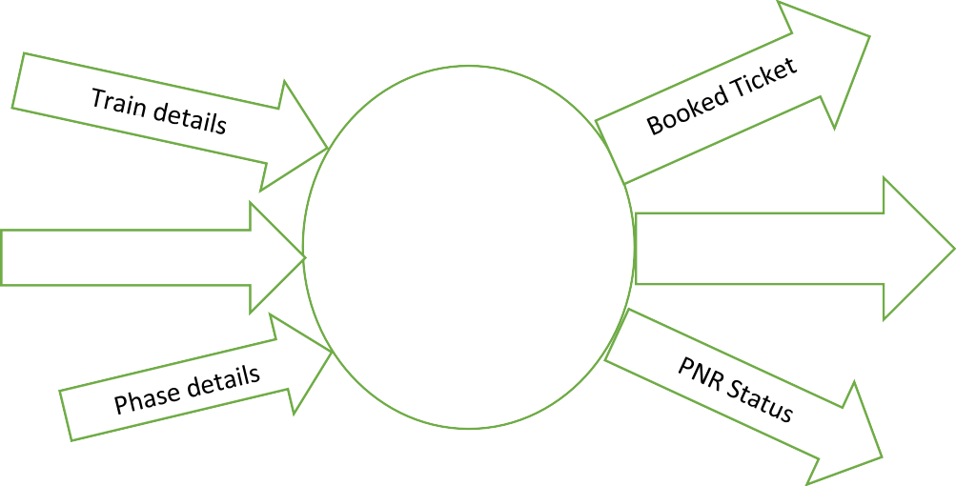

Step 2: Add all Inputs and Outputs to the system.

Passenger details

Train Ticket

Booking system

Cancelled Ticket

### Output:

0-level DFD is developed for ticket booking system which shows a basic Data Flow Diagram.

## Problem:

* 1. Develop level-1 DFD for the Train Ticket Booking System.

### Procedure:

Break activities into details for ex:

1. User details can also be defined as a bubble where Input and Output are connected.

User details

Login

Login done

Similarly, Ticket Booking and Ticket cancellation can be represented in more details.

Ticket

cancellation

Print cancelled ticket



Reservation data

Passenger

Print cancel Ticket

Train details

Ticket

Cancellation

Enquiry

Registration

System

Login

Ticket

Booking

Registe r

User details

Ticket

Booking

Print booked ticket

The complete level 1 DFD is given below: Print Booked ticket

# Practical No: 4

## AIM: Use Gantt Chart/Project as a Project management Tool.

### Introduction:

Gantt Chart is a tool for project management used to allocate resources to activities.

### Procedure:

A Gantt Chart can be prepared as shown below by showing all activities on a chart with respect to time.

|  |  |  |  |  |
| --- | --- | --- | --- | --- |
| Phase-1 | Phase-2 | Phase-3 | Phase-4 | Phase-5 |
| Req. gathering  Analysis | Design | Coding | Integrate Test | Deployment |
| Documentation | | | | |

Gannt Chart show scheduling a project with time limits.

**STEP TO CREATE A GANTT CHART**

**Step 1: Identify essential tasks:** like in above case. Req. gathering and analysis, design, coding, testing, deployment are the essential tasks required.

**Step 2: Identify task relationship:** It shows relationship between task in a project. Some tasks start after one task completes. For example, in above example documentation task is there from start to end.

**Step 3: Draw chart using a templet:** Create graph of activities/tasks as shown above.

**Step 4: Measure Chart Progress:** Measure the progress of the chart i.e. everything is moving as per scheduled time or not.

# Practical No: 5

## AIM: To develop sequence diagram pf given problem:

### Problem:

In sequence diagram all process of a system are represented in a sequence.

For example, we have to change our login password to a system the detailed sequence of process will be:

User Login detail form login detail controller login details

1. Enter details

2. Submit details

3. Change/Add details

4. Successfully updated

### Output:

A sequence diagram which shows the step of a process in a sequence.

# Practical No: 6

## AIM:

Take a system, study it’s specification and report various bugs: Let’s take example of ATM System.

### Features to be Tested:

1. Validity of card
2. Withdraw flow of ATM
3. User Authentication
4. Dispense Cash from account
5. Verify the balance enquiry
6. Change of ATM PIN

**Bug Identified:**

|  |  |
| --- | --- |
| **Bug ID** | **Bug Name** |
| ATM-001 ATM-002 ATM-003 ATM-004 ATM-005 ATM-006 ATM-007 ATM-008  ATM-009 | Invalid Card Invalid PIN  Invalid Account Type  Insufficient Balance Transaction Limit Day Limit  Invalid Money  Denominations  Receipt Not Printed  PIN Change Mismatch |